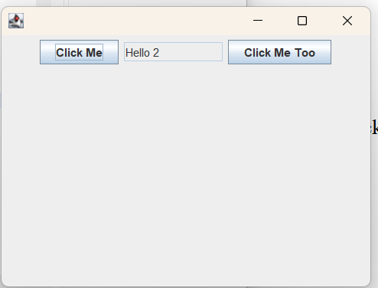

package as10;

public class TestJFrameExt
{
public static void main(String[] args)
{
// Create a JFrameExt object
JFrameExt f = new JFrameExt();

// Set the size of JFrameExt object to 400 by 300
f.setSize(400, 300);

// Make the JFrameExt object show up
f.setVisible(true);
}
}

